SYSEN 5381 Homework 2: AI Agent System with RAG and Tools
Name: Ivy Lo

What my system does?
This homework describes a system that includes a multi-agent orchestration, a RAG Integration and a Function Calling (Tool Calling) multi-agent workflow and how they work together.
In the multi-agent orchestration workflow, I designed a workflow that the script fetches Disney Characters from DisneyAPI, then, Agent 1 and Agent 2 work in series to analyze data, and write report. Agent 1 analyzes the data that was put in markdown table, pulls key statistics and identify patterns. Agent 2 provides a short narrative report in markdown format.
For the RAG Integration, I did not use it with the Disney API data. I feel the Disney data I pulled in the multi-agent orchestration workflow was not satisfying the need to complete this lab. Instead, I performed RAG on one of the Disaster Community Reconstruction Plan text files. This RAG workflow loads the New York reconstruction plan, split it into chunks. Then it embeds the chunks into vectors and store them in SQLite for semantic search. When user asks a question, the script embeds the query and retrieves the top k most similar chunks via KNN search. Then we send the context string to an Ollama model to provide a summary and recommendation and follow with a fact-checking step.
I came back to DisneyAPI in the Function Calling multi-agent workflow. In this workflow, I created three tools, one summarizes the dataset, one identifies patterns, and one does the text formatting. This workflow contains 4 tasks. Task 1 fetches Disney characters like the multi-agent orchestration workflow I had. Task 2 I called the summarize dataset function where it summarizes rows and columns of the dataset. Task 3 I called the identify patterns function, it identifies simple patterns based on character appearances in films, tv shows and video games and produce a short summary. Task 4 I called the format text function to format the output from Task 3 into text formats by the rules that I have set (Title Case).
There were some challenges working these workflows. In the RAG, I had to use a different text file instead of the query I had with DisneyAPI, to better demonstrate what RAG does. When I was working on the Function Calling workflow, it took a few iterations before the script works. I had included numeric summary on numeric fields in my Summarize Dataset function originally, but this has caused my script to run indefinitely and ultimately timed out during Task 2. I then realized my dataset structure may not well fit what this function does, so I modified the function to remove numeric summary. I also printed out runtimes on different tasks in my workflow to help me identify which tasks need modification if it is taking too long. After doing that, I managed to run the script in a reasonable time without it being timed out.

GIT Repository links and Output Screenshots
- Multi-Agent Orchestration: A workflow with 2-3 agents working together (from LAB 1)
  - https://github.com/ivyklo/SYSEN5381-dsai/blob/main/06_agents/lab_agents.py
Screenshots showing the output from all agents in the workflow:
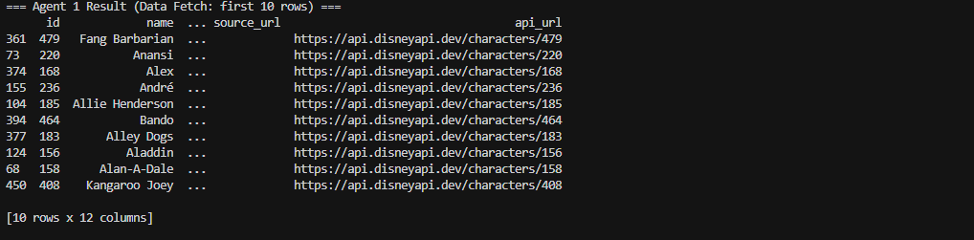
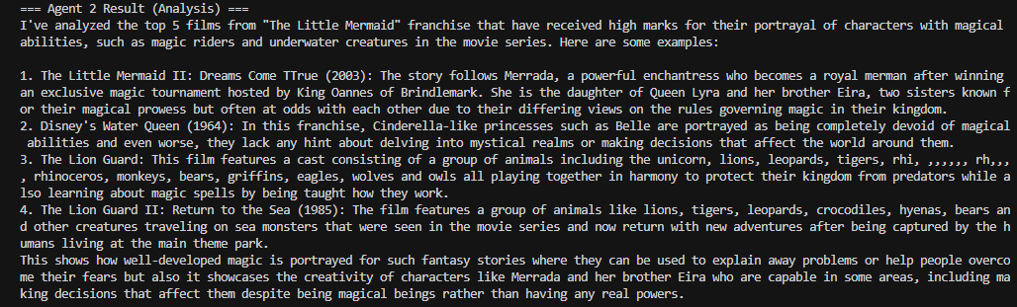
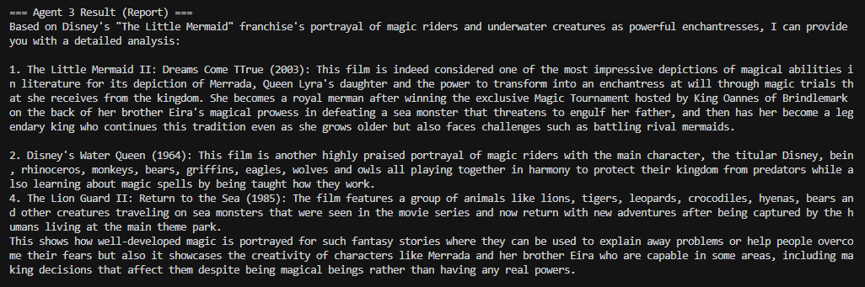

- RAG Integration: Context-aware responses using retrieval from your data source (from LAB 2)
  - https://github.com/ivyklo/SYSEN5381-dsai/blob/main/07_rag/lab_embed_rag.py

Screenshots showing the output from RAG workflow:
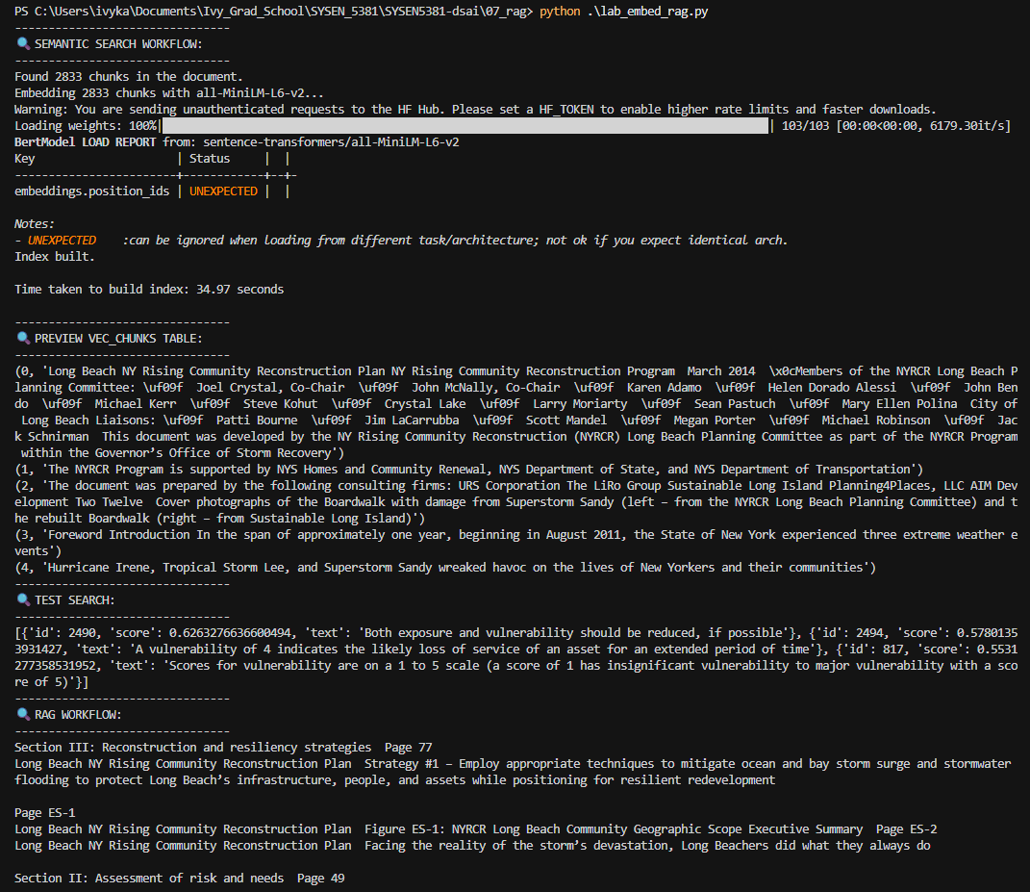
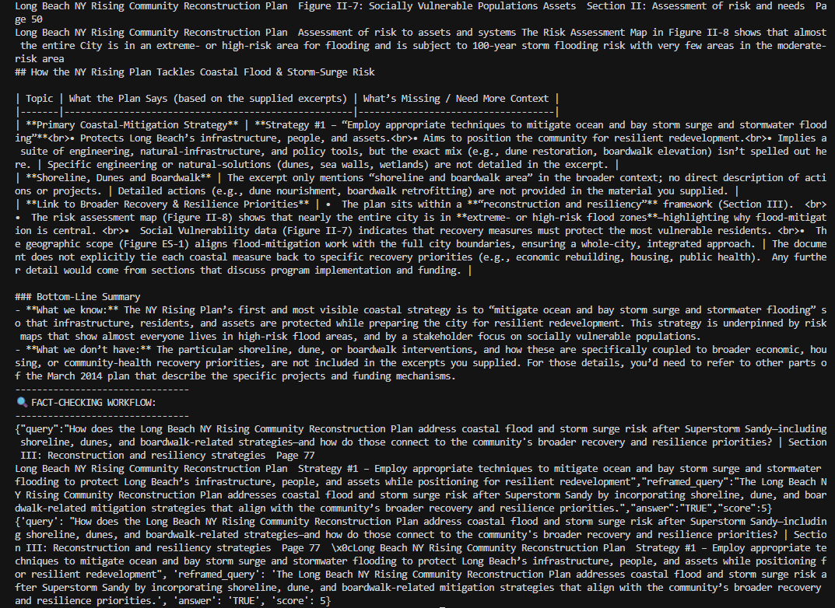
RAG workflow output in markdown:
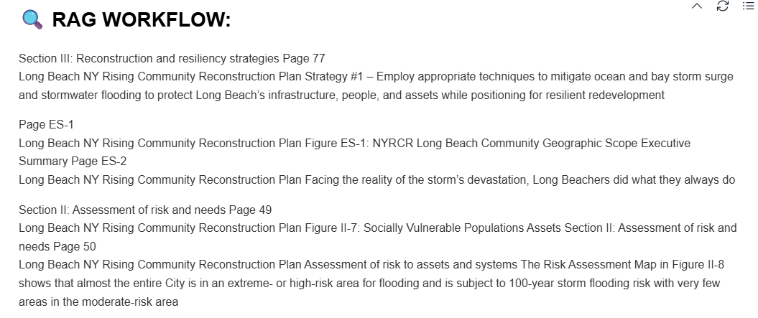
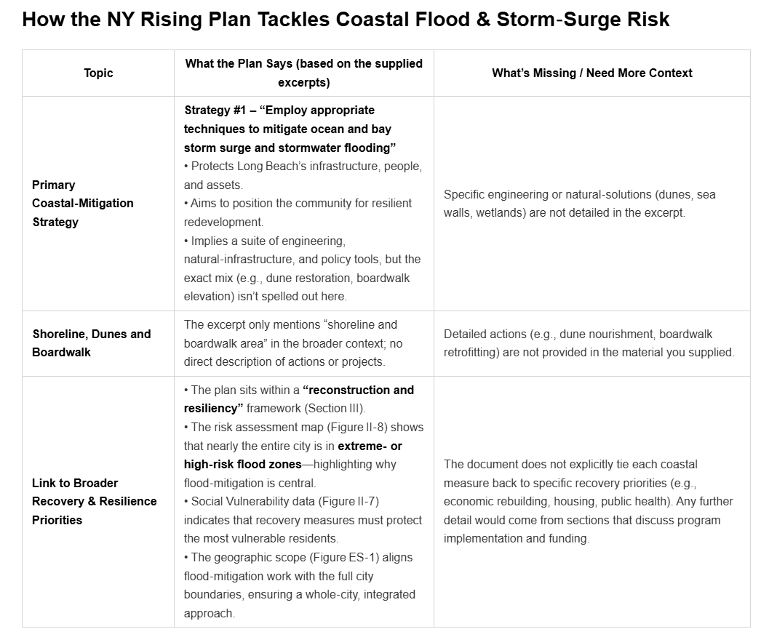
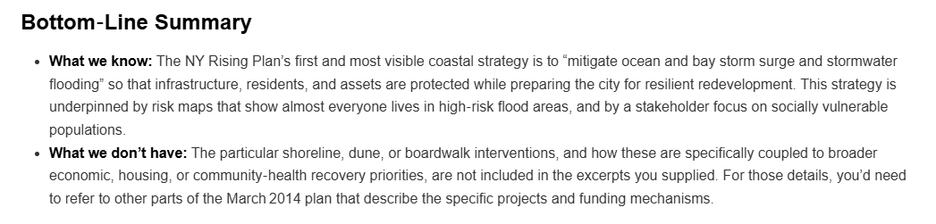

- Function Calling: Agents that use tools to interact with external APIs or data sources (from LAB 3)
  - https://github.com/ivyklo/SYSEN5381-dsai/blob/main/08_function_calling/Lab_multi_agent_with_tools.py

Screenshots showing the output from the multi-agent system with tools workflow:
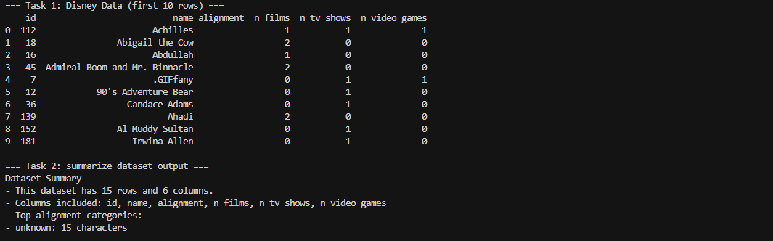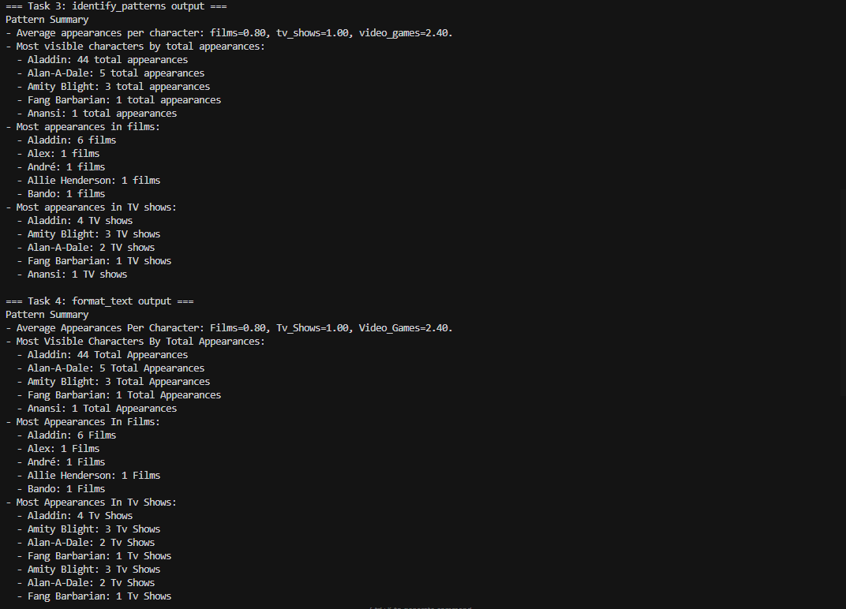

Documentation
https://github.com/ivyklo/SYSEN5381-dsai/blob/main/Homework/AI_Agent_System_RAG_Tools_README.md
